**Free Body Diagram Practice**

* Identify all of the forces acting on the object.
* Draw a labeled free-body diagram for it.
* (Optional) Draw a picture of what is happening in each case.

**Choices of Forces**: Applied, Friction, Gravity, Normal, Tension

1) A squirrel sits still on a tree branch.

PICTURE FORCES FREE BODY DIAGRAM

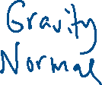

2) A bucket hangs still from a string.

PICTURE FORCES FREE BODY DIAGRAM

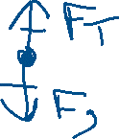

3) The bucket is being pulled upwards at a CV.

PICTURE FORCES FREE BODY DIAGRAM

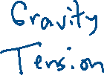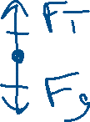

4) The bucket is being pulled upwards, and it is speeding up.

PICTURE FORCES FREE BODY DIAGRAM

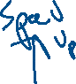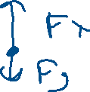

5) The string breaks, and the bucket goes into freefall.



PICTURE FORCES FREE BODY DIAGRAM

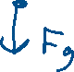

6) A hotel worker stands in a downward accelerating elevator.



PICTURE FORCES FREE BODY DIAGRAM

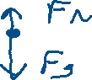

7) A UPS worker is pushing on a heavy cart to the right, and makes it speed up.



PICTURE FORCES FREE BODY DIAGRAM

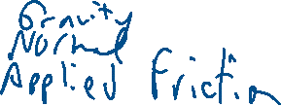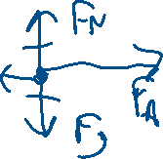

8) A UPS worker is pushing on a heavy cart to the right, and it moves at CV.

PICTURE FORCES FREE BODY DIAGRAM

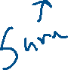

9) A UPS worker is pushing on a heavy cart to the right, and it is slowing down.



PICTURE FORCES FREE BODY DIAGRAM

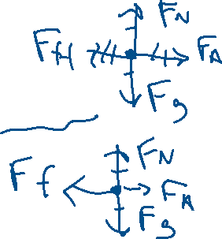

10) A soccer ball is rolling to the right, and slowing down due to friction.

PICTURE FORCES FREE BODY DIAGRAM

